# while

|  |  |
| --- | --- |
| while (test_expression)  {  // statements    update_expression;  } | while (test_expression)  // single statement in while only  //curly braces are optional but only one single statement will be executed |

**Java while loop** is a control flow statement that allows code to be executed repeatedly based on a given Boolean condition. The while loop can be thought of as a repeating if statement. While loop in Java comes into use when we need to repeatedly execute a block of statements. The while loop is considered as a repeating if statement. If the number of iterations is not fixed, it is recommended to use the while loop.

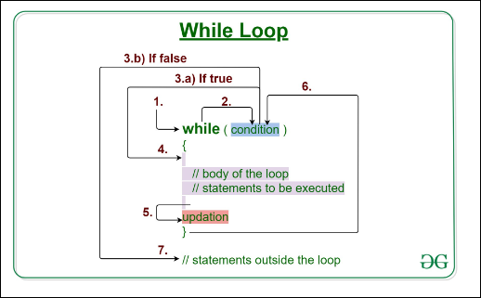

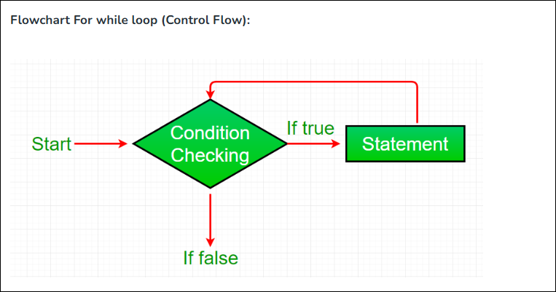

|  |  |
| --- | --- |
| int value = 10;  while(value){} | Not a valid syntax |
| while(value=10){} | Not a valid syntax |
| while(value==10){} | Value syntax, condition is Boolean returns true or false |
| while(true){} | is valid syntax but excute infinite times. |
| class whileLoopDemo {      public static void main(String args[])      {          // initialization expression          int i = 1;            // test expression          while (i < 6) {              System.out.println("Hello World");                // update expression              i++;          }      }  } | Hello World  Hello World  Hello World  Hello World  Hello World |
| class whileLoopDemo {      public static void main(String args[])      {          int x = 1, sum = 0;            // Exit when x becomes greater than 4          while (x <= 10) {              // summing up x              sum = sum + x;                // Increment the value of x for              // next iteration              x++;          }          System.out.println("Summation: " + sum);      }  } |  |

## do while loop

do{

// Loop Body

Update_expression

}

// Condition check

while (test_expression);

test expression must be a Boolean value.

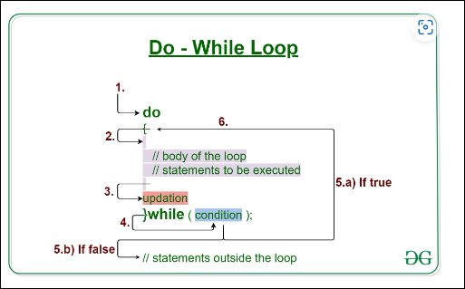

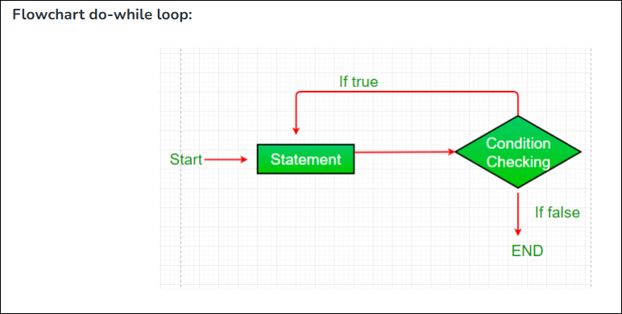

|  |  |
| --- | --- |
| class Test {        // Main driver method      public static void main(String[] args)      {          // initial counter variable          int i = 0;            do {                // Body of loop that will execute minimum              // 1 time for sure no matter what              System.out.println("Print statement");              i++;          }            // Checking condition          // Note: It is being checked after          // minimum 1 iteration          while (i < 0);      }  } |  |
|  |  |
|  |  |
|  |  |
|  |  |